PRACTICAL 3
Code: https://github.com/bhavyakumar18/DSA/tree/main/Practical%203
Problem 1:
I faced difficulty in understanding the difference between Bubble Sort, Selection Sort, and Insertion Sort and how each method arranges the elements. I solved this by understanding the working of each method step by step and then implementing them separately. I practiced comparing, swapping, selecting the smallest element, and inserting elements into the correct position. This helped me understand the three sorting methods clearly.
Output:
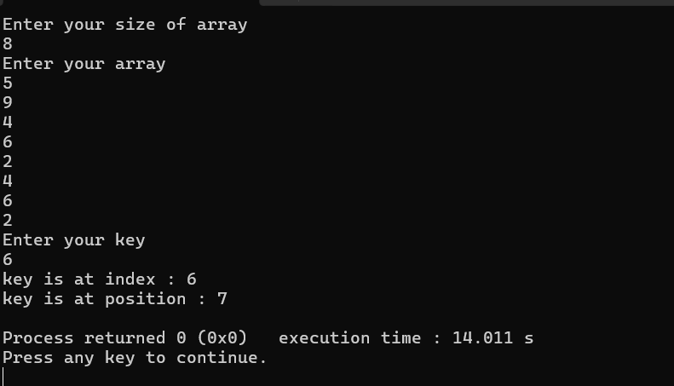
Problem 2:
I faced difficulty in arranging 0, 1, and 2 in the correct order without using extra storage. I solved this by using the three-pointer approach, where one pointer handles 0, one handles the current element, and one handles 2. By swapping the elements according to their values, I was able to arrange the array in place and understand how the problem can be solved in one pass.
Output:
